Kenya

## Freedom House political status

The data set shows the Freedom House political scores and status of the country each year.

## # A tibble: 19 x 5  
## country iso3c date mean status   
## <chr> <chr> <dbl> <dbl> <chr>   
## 1 Kenya KEN 1996 6.5 Not Free   
## 2 Kenya KEN 1998 5.5 Not Free   
## 3 Kenya KEN 2000 5.5 Not Free   
## 4 Kenya KEN 2002 4 Partly Free  
## 5 Kenya KEN 2003 3 Partly Free  
## 6 Kenya KEN 2004 3 Partly Free  
## 7 Kenya KEN 2005 3 Partly Free  
## 8 Kenya KEN 2006 3 Partly Free  
## 9 Kenya KEN 2007 3.5 Partly Free  
## 10 Kenya KEN 2008 3.5 Partly Free  
## 11 Kenya KEN 2009 4 Partly Free  
## 12 Kenya KEN 2010 3.5 Partly Free  
## 13 Kenya KEN 2011 3.5 Partly Free  
## 14 Kenya KEN 2012 4 Partly Free  
## 15 Kenya KEN 2013 4 Partly Free  
## 16 Kenya KEN 2014 4 Partly Free  
## 17 Kenya KEN 2015 4 Partly Free  
## 18 Kenya KEN 2016 4 Partly Free  
## 19 Kenya KEN 2017 4 Partly Free

## Freedom House classification of political change

The data set shows the GDP growth and the ecomic growth classification of the country each year.

## # A tibble: 19 x 4  
## country iso3c date politicalChangeFH  
## <chr> <chr> <dbl> <chr>   
## 1 Kenya KEN 1996 no change   
## 2 Kenya KEN 1998 democratization   
## 3 Kenya KEN 2000 no change   
## 4 Kenya KEN 2002 democratization   
## 5 Kenya KEN 2003 democratization   
## 6 Kenya KEN 2004 no change   
## 7 Kenya KEN 2005 no change   
## 8 Kenya KEN 2006 no change   
## 9 Kenya KEN 2007 autocratization   
## 10 Kenya KEN 2008 no change   
## 11 Kenya KEN 2009 autocratization   
## 12 Kenya KEN 2010 democratization   
## 13 Kenya KEN 2011 no change   
## 14 Kenya KEN 2012 autocratization   
## 15 Kenya KEN 2013 no change   
## 16 Kenya KEN 2014 no change   
## 17 Kenya KEN 2015 no change   
## 18 Kenya KEN 2016 no change   
## 19 Kenya KEN 2017 no change

## Freedom House score trend

The plot shows the Freedom House scores trend of the country.

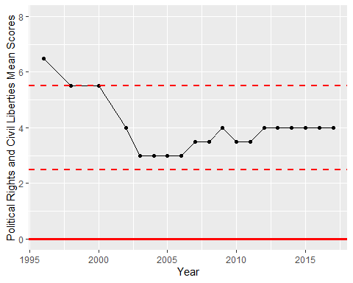

Freedom House Score Trend